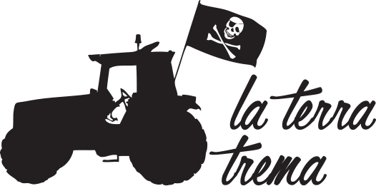
self-certification and source price

Name who identifies the producer

Village (Municipality – State)

THE PRODUCER
Business name:
Address (street, postcode, village and municipality, province, state):
Phone:
E-mail:
Website:
Owner:
Possibility to visit the farm/winery (yes or no, if yes indicate on which days):
Accommodation facilities (type and number of places):
Services in the farm (agritourism, bed&breakfast, restaurant...):
Products that can be purchased in the farm:
Description of the family nucleus and their involvement in agricultural activities (brief description):
Total cultivated area (hectares):
*Cultivated area with vines (hectares):
*Cultivated area with olives (hectares):
*Other crops (which):
Ownership of the land (if a part is rented, specify its extension):
Agricultural management (conventional, low impact, organic, biodynamic, with or without certification, other peculiarities):
Certification company name, when used:
Analysis laboratory name, when used:
Enologist or winemaker (specify when only a consultant):
Agronomist or agricultural manager (specify when only a consultant):
Permanent workers (indicate the number):
Seasonal workers (indicate the number):
Type of work contract used for permanent workers:
Type of work contract used for seasonal workers:
Use of temporary work (yes or no, frequency):

*Wines (list the wines one by one and, when present, specify Protected Designation of Origin, cru/village, fantasy name):
*Total number of bottles produced per year (of wine, on avarage):
*Total number of litres of oil produced per year (on average):
Direct sale (specify if in the farm, markets, fairs, and the percentage):
Sales in the medium and / or large distribution (specify the percentage and in which chains):
*Total sales last year, wine only (specify sales volume and direct sales):
*Total sales last year, oil only (sales volume and direct sales):
A brief history of the producer/company:
Historical and geographical mention of the territory (summary information):
Environmental conditions of the place and the production area (possible environmental risks):
My principles and ideals as a producer:
My opinion on the use of GMOs:

